Best Practices for Object Diagram
An Object Diagram represents instances of classes at a particular moment in time. It's crucial for understanding the state of the system and how objects are related.

1. Keep it Simple and Focused
- Show only relevant objects: Avoid overloading the diagram with too many objects. Only include those that are necessary to represent the scenario being modeled.
- Limit the number of instances: Focus on a subset of objects that represent a specific scenario or interaction.

2. Use Clear Object Names
- The object name should be clear and descriptive. It should represent the instance and sometimes its state (e.g., John_Student).
- Include the object's class name, followed by its current state (e.g., student1:name="John", grade="A").

3. Show Important Relationships
- Represent associations and references clearly by showing relationships between objects (e.g., Student has a Result).
- Use simple lines to show associations and arrows to represent dependencies.

4. Consistency
- Ensure that object names, attribute values, and the diagram’s layout remain consistent with other parts of your design.
- When using attributes in object instances, use consistent formats, such as showing the values in a specific format (<attributeName>:<value>).

5. Avoid Redundancy
- Don't repeat information that is already present in the Class Diagram unless necessary for the scenario.
- Object Diagrams should only depict the state of objects, not duplicate the class-level design.

Best Practices for Class Diagram
A Class Diagram provides a static view of the system’s structure, representing classes, attributes, methods, and relationships.

1. Keep it Simple and Abstract
- Focus on high-level classes and avoid unnecessary details. Only include the attributes and methods that are essential for understanding the system's structure.
- Avoid overcomplicating with too many classes, especially in the initial stages of design.

2. Use Meaningful Names for Classes and Attributes
- Class names should be nouns that clearly describe the object or concept (e.g., Student, Course, Result).
- Attribute names should describe the characteristics of the object (e.g., studentId, email, grade).
- Method names should represent actions (e.g., enrollInCourse(), assignGrade()).

3. Define Relationships Clearly
- Clearly define the types of relationships between classes using appropriate UML notations:
  - Association: Represented by a simple line, indicating that classes are related.
  - Inheritance: Represented by a line with a triangle, indicating a superclass/subclass relationship.
  - Aggregation/Composition: Represented by lines with diamonds, denoting "whole-part" relationships (composition has a stronger relationship than aggregation).
- Use the right multiplicity (e.g., one-to-many, many-to-many) to describe how classes are related.

4. Show Interfaces and Abstract Classes When Needed
- If you're modeling interfaces, use the dashed line with a triangle pointing to the implementing class. This clarifies which class is fulfilling a contract.
- Abstract classes should be represented with italics or a clear indication that they cannot be instantiated.

5. Use Proper Access Modifiers
- Indicate whether attributes and methods are public, private, or protected (e.g., +, -, #).
- This helps clarify the visibility and encapsulation of each component in the class.

6. Group Classes into Packages
- In larger systems, group related classes into packages. This reduces clutter and improves readability.
- Use packages to logically group related classes (e.g., student, course, results).

Best Practices for Sequence Diagram
A Sequence Diagram models the interaction between objects over time, focusing on the sequence of messages.

1. Clear and Consistent Object Naming
- The objects in the diagram should be clearly labeled with meaningful names. Use class names followed by object identifiers (e.g., Student1, Teacher_MrSmith).
- Use consistent naming conventions for messages, such as placeOrder(), enrollInCourse().

2. Limit the Number of Objects in the Diagram
- Too many objects can make the sequence diagram cluttered and hard to read. Limit the number of objects to only those essential for the particular scenario you’re modeling.
- If necessary, break complex interactions into smaller diagrams.

3. Represent Lifelines and Activations Properly
- Lifelines represent the existence of objects and are drawn as dashed vertical lines.
- Activation bars represent when an object is active and performing a task. Ensure that the lifeline’s activation bar is clearly defined for each method call.

4. Use Clear and Meaningful Messages
- Messages should clearly indicate what is happening between the objects. Use consistent naming conventions for method calls (e.g., getStudentResult() or calculateGrade()).
- Return messages should be dashed arrows, indicating that the method has completed and returned control or a value to the calling object.

5. Ensure Proper Message Ordering
- Messages in a sequence diagram should be drawn in top-to-bottom order to reflect the logical sequence of operations. The first message should appear at the top, followed by the subsequent messages.
- Use arrows to indicate the flow of communication, with clear labels for each message.

6. Show Conditionals and Loops When Needed
- If the flow depends on certain conditions, use alt (alternatives) or opt (optional) boxes to represent decision points or optional operations.
- For loops or repeated actions, use loop boxes and clearly show the repetition.

7. Keep It Focused on a Single Use Case
- Each sequence diagram should represent a single use case or scenario, making it easier to follow.
- Avoid combining multiple interactions in one sequence diagram. If a scenario has multiple branches or steps, create separate diagrams for each.

Sample Problem 1: School Results Application

Class Diagram
The class diagram represents the structure of a school results application where students have subjects, and their scores are calculated for grades.
Diagram Description:
- Classes: Student, Subject, GradeCalculator
- Relationships:
  - A Student has multiple Subject entries (Aggregation).
  - GradeCalculator computes the results for a Student.

→ Draw the Class Diagram
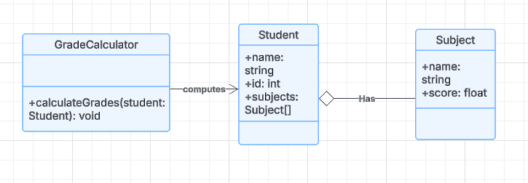

Object Diagram

An object diagram provides a snapshot of the Student and their Subject objects at a particular point.
Example:
- Student: John
- Subjects: Maths, Science
- Marks: 90, 85

→ Draw the Object Diagram
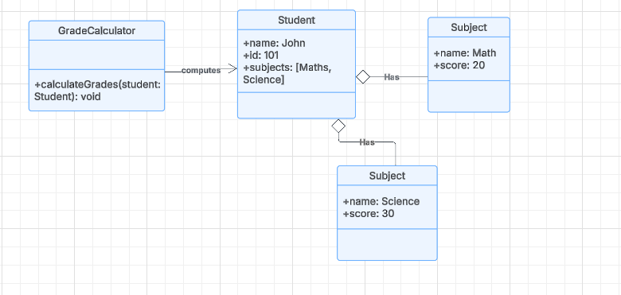

Sequence Diagram
The sequence diagram shows how objects interact to calculate grades.
Scenario: A student requests their grade based on marks in subjects.
Actors:
- Student
- GradeCalculator
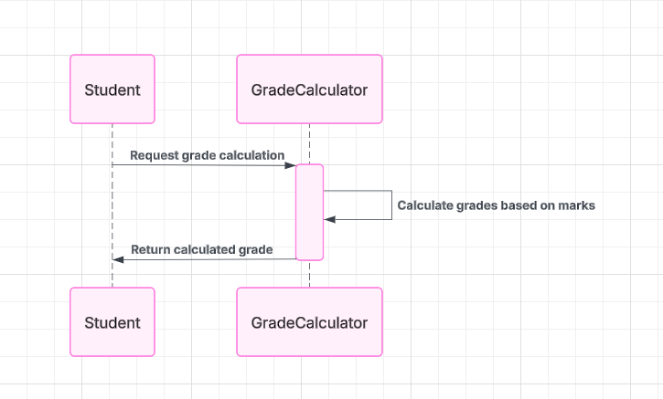

Sample Problem 2: Grocery Store Bill Generation Application

Class Diagram
The class diagram models the system where a customer buys products, and the bill is generated.
Diagram Description:
- Classes: Customer, Product, BillGenerator
- Relationships:
  - A Customer can purchase multiple Product items (Composition).
  - BillGenerator computes the total for the Customer.

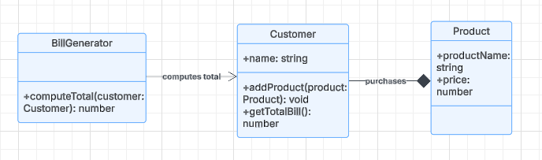

Object Diagram
An object diagram shows the details of a Customer and the Product objects they have purchased.
Example:
- Customer: Alice
- Products:
  - Apples (2 kg at $3 per kg)
  - Milk (1 liter at $2 per liter)
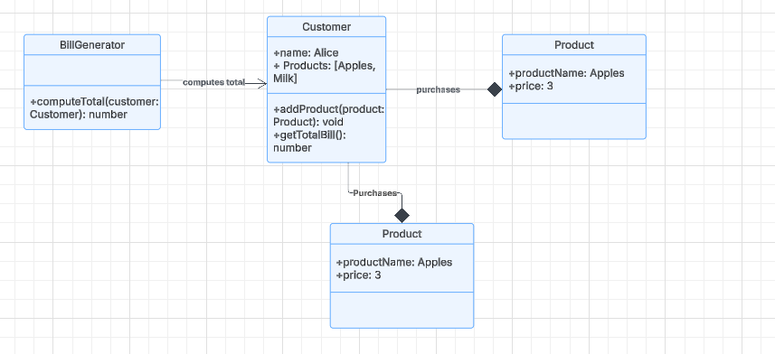

Sequence Diagram
The sequence diagram shows the process of bill generation for a customer.
Scenario: A customer checks out at the grocery store, and the total bill is generated.
Actors:
- Customer
- BillGenerator

→ Draw the Sequence Diagram

Comparison of the Two Scenarios
Feature | School Results Application | Grocery Store Bill Application
Classes | Student, Subject, GradeCalculator | Customer, Product, BillGenerator
Relationships | Aggregation | Composition
Primary Functionality | Calculate grade | Generate total bill
Key Entities | Students, Subjects, Grades | Customers, Products, Bills

